www.pixlr.com
Pixlr is a wonderful FREE app that allows users to crop, resize, rotate, adjust and add photo effects to your photos. It is user friendly and should be easy for the kids to use to complete their pop art photo project! For our purposes, here are the steps we will follow to upload, and add effects to our photos!
First, go to www.pixler.com
Once you are in pixler, there are three levels for photo editing. With our group, we will use the pixler o-matic. The students will need to take their pictures and save them to their student H drives before they can start their project. Click on pixler o-matic:
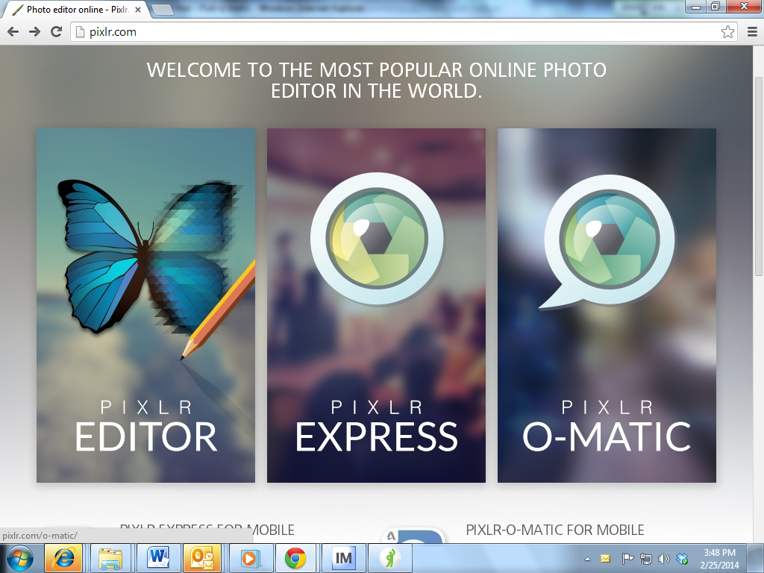

Once we open the pixler o-matic, students will click on the photo image and will go to their H drives to retrieve the photos that they took.
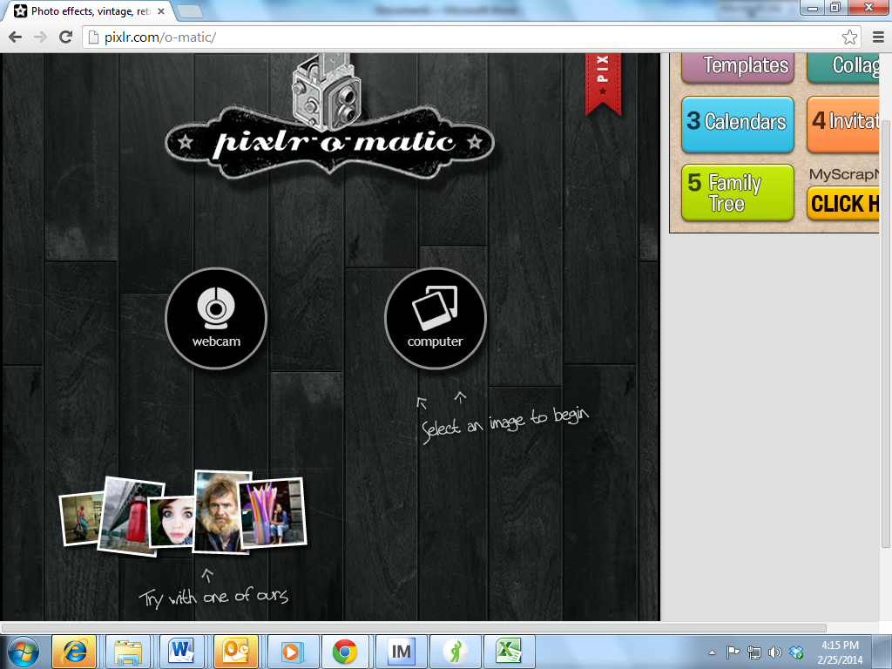

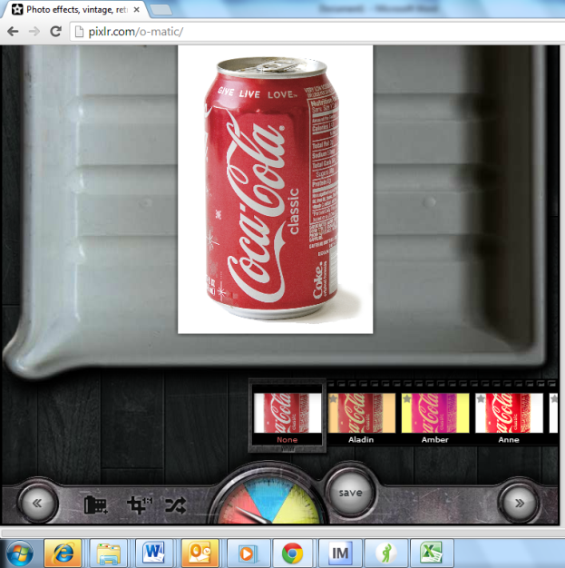
Once they click on their pictures, it will bring it up in a tray that looks like this. There is a crescent at the bottom with pink, blue and yellow. This is where you can find the photo effects and what we will use to alter the images. You move the needle in the crescent to make the following changes to the images:

Pink – effects
Blue – overlays
Yellow- borders

Effects:
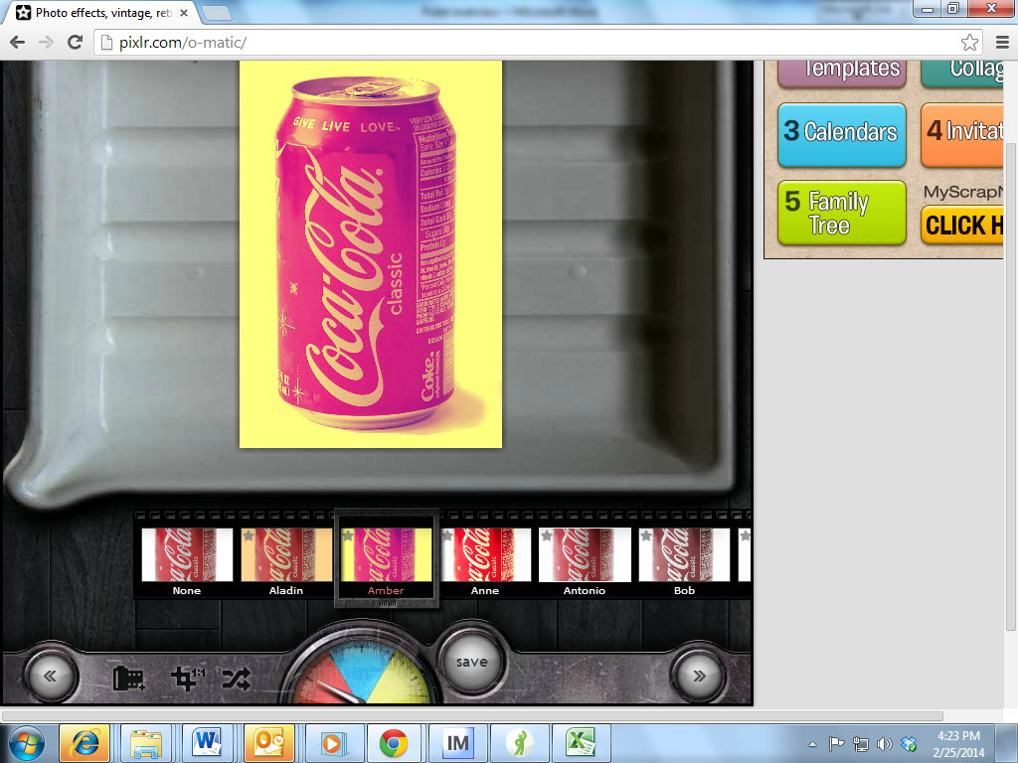

Picture effects

At the bottom, above the crescent, you will see different effects that you can choose to apply to your picture. To apply the effect, simply click on the box. The boxes will automatically advance to the left to show you more options (I clicked on Amber for my affect). If you want to have two effects on one image, you would apply your first effect and then save the new image ( I will show you this later) and then open the saved image to apply a different effect.

Overlay
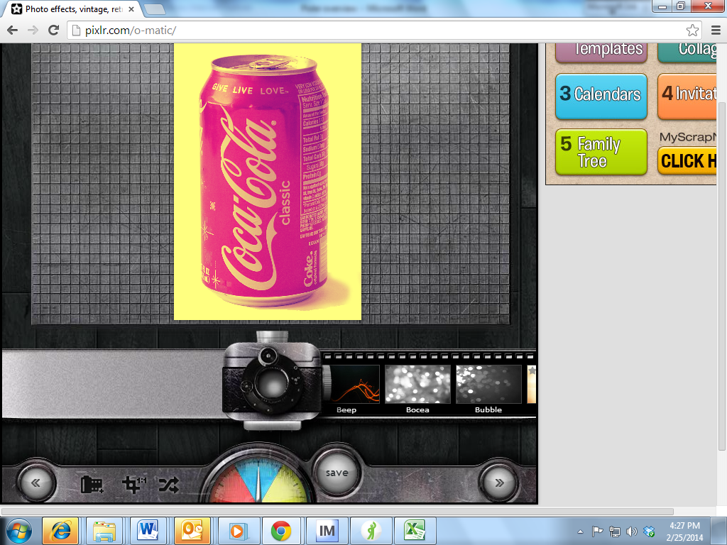

Overlays

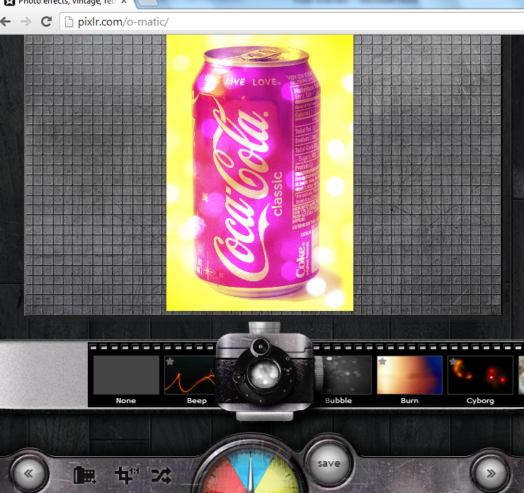
To add an overlay, move the needle to blue (the camera and a filmstrip will appear). To add an overlay, simply click on the overlay that you want to add. Again, the film will advance as you click on each option to show you more options. I have added a Bocea overlay to my original picture:

Borders
To add a border, move the needle to yellow. The camera will go away, but on the filmstrip will be options for borders. Just as above, click on the square with the border affect that you want for the picture.
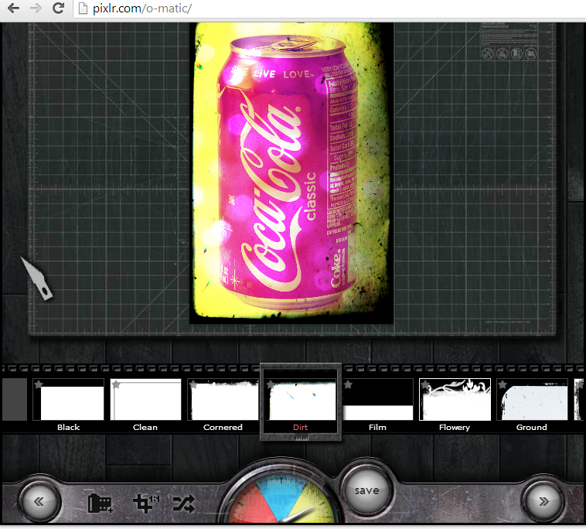

Borders
(yellow )

Now you are ready to save your image! Click on the save button:

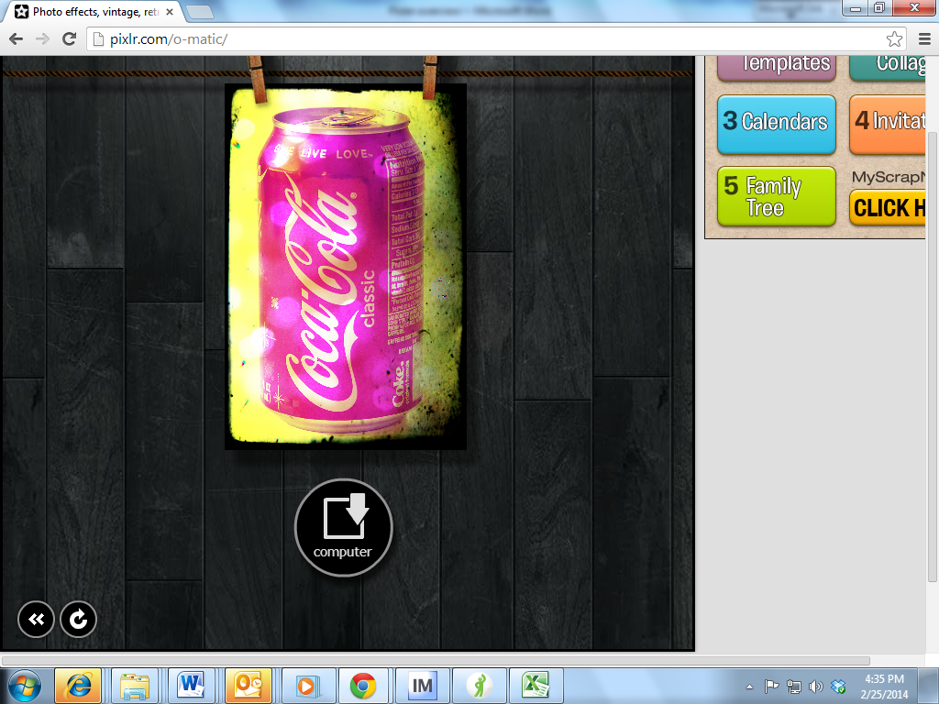
- You will click the computer icon.
- A box will pop up where you will save your image.
- Click on the double arrows.

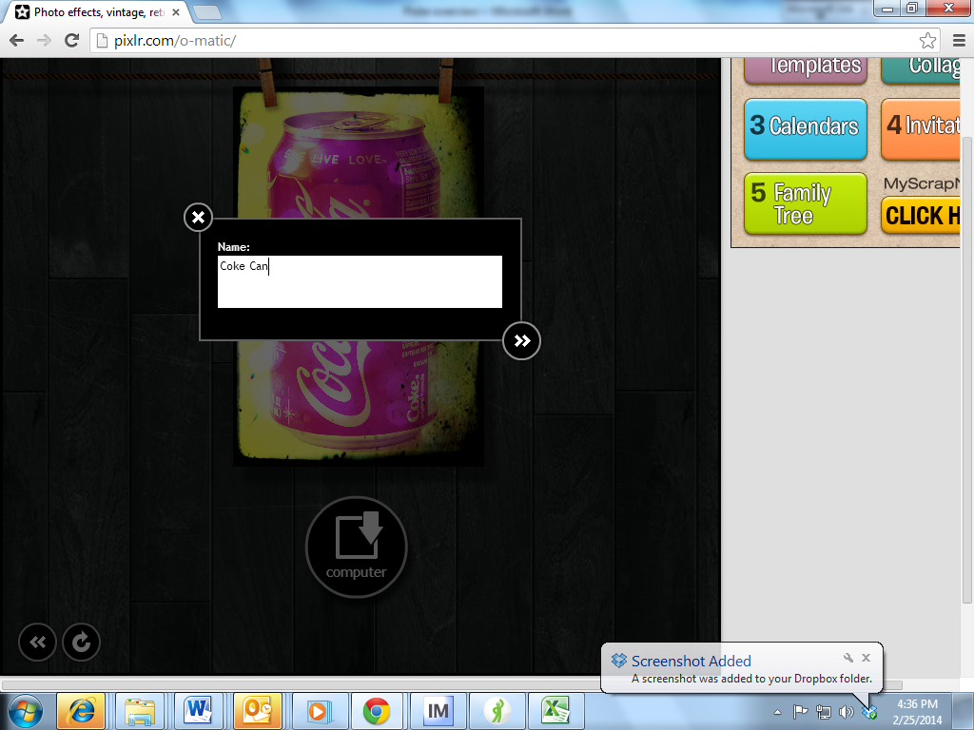

The students will then save it in the appropriate folder in their H drive.

